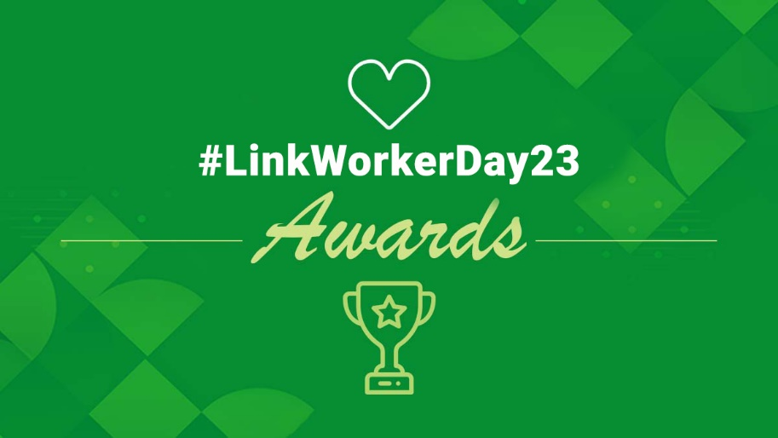
LinkWorkerDay23 Awards Nomination Pack

National Association of Link Workers is delighted to present the #LinkWorkerDay23 Awards to celebrate Social Prescribing Link Workers’ impact and recognise all those who have made outstanding contributions in Transforming Healthcare for All through social prescribing.

Award Categories:

Social Prescribing Employer of the Year
Social Prescribing Link Worker of the Year
Social Prescribing Partnership of the Year
*NEW* Social Prescribing Supplier of the Year

Key dates:
- Nominations close 16th January 2023.
- Shortlist announced 27th February 2023.
- The winner will be announced at the #LinkWorkerDay23 awards ceremony, on 27th April, at the HealthCare Show ExCel London.

Judges: National Association of Link Workers senior management and selected industry stakeholders

Award Categories

Social Prescribing Employer of the Year
This award recognises a Social Prescribing Link Worker employer that has shown outstanding commitment to their Social Prescribing Link Worker and communities in which they operate, which have helped transform healthcare for all. This employer went the extra mile to empower and champion social prescribing link workers to flourish and can evidence this through their activities and processes.
Each nomination will be judged against these criteria:
- How Social prescribing link Workers have been embedded in the organisation.
- How they promoted employee welfare and engagement
- Innovation and operational excellence
- Employee communication/feedback mechanisms
- Supporting the local community
- Evidence of a robust recruitment process and induction
- Employee learning and development programmes and ongoing investment in staff
- Demonstrate the impact that staff development schemes have had on company performance
- Examples of effective leadership and how this helps with staff performance
- Opportunities for career progression, training, retention
- A diverse, equal, and inclusive work culture
- Innovative workforce strategy
- Strength of evidence of impact on lives, communities and Healthcare
You can nominate yourself or another.

Social Prescribing Link Worker of the Year
This award recognises an inspirational Social Prescribing Link Worker, representing excellence in Social Prescribing Link Worker professional practice, and has been in the post for a minimum of 1 year. This person is a transformer who has gone beyond day-to-day expectations to overcome significant challenges to achieve success in transforming Healthcare for All and can evidence the impact of their work.
Each nomination will be judged against these criteria:
- Strength of evidence of impact on lives, communities and healthcare
- Inspires others and shares learning
- Excellence in Social Prescribing Link Worker professional practice
- How they are improving themselves to be the best they can be in their role
- Transformer-demonstrates creative ways of transforming Healthcare for All
- Flexibility in approach
- Challenges faced and how they have overcome them
- How they have worked in collaboration with inter-professionals and inter-agencies to meet needs
You can nominate yourself or another.

Social Prescribing Partnership of the Year
This award recognises an outstanding, collaborative social prescribing partnership. The partnership may be a place based, neighbourhood or a system level partnership to promote their areas health, and reduce inequalities.
Each nomination will be judged against these criteria:
- How the partnership has achieved success and transformed healthcare for all
- An innovative approach to addressing health inequalities and improving access to care
- Strength of collaboration with inter-professionals and inter-agencies to meet needs
- Evidence of partnership effectiveness
- Inspires others and shares learning
- A strategic approach to coproduction and engaging Link Workers
- Proof of a partnership that is impactful on stakeholder outcomes
- Demonstrates a commitment to diversity, equity, and inclusion
- Evidence of coproduction with local communities (including lived experience) and social value
You can nominate yourself or another.

Social Prescribing Supplier of the Year
This award recognises an outstanding, Social Prescribing supplier. This may be a recruiter, technology or education supplier, which has provided an outstanding product/support/guidance/service to a social prescribing client or customer to advance the link worker model to transform healthcare for all.
Each nomination will be judged against these criteria:
- How significant are the benefits to the social prescribing client/link workers/patients/communities/healthcare
- How unique/innovative is the product/service/support that is being offered
- How much does the entry demonstrate going ‘above and beyond’
- Evidence to demonstrate supplier effectiveness and quality improvement
- How easily can the examples in the entry be applied to a wide variety of situations/customers
- Evidence of social value
- Proof of excellent customer service
You can nominate yourself or another.

Nomination Form

Please complete the details below. All questions with an asterisk (*) must be answered in order to submit the nomination.

Should you have more than one nomination, please continue on a separate nomination form.

Please email your completed nomination to awards@nalw.org.uk

Your details: Please provide the details of the person making this nomination *
Title *
First name *
Surname *
Job Title *
Organisation *
Email Address *
Contact number *

Category: Please indicate the category this nomination is for *

Nominee: Please indicate the name of the person/organisation this nomination is for *

Nominee Details:
Please enter the details of the most appropriate person to contact should this nomination be successful. If you are nominating a team, please add the details for one person within that team.

Please confirm by saying “yes” that you have informed the team/individual that you are nominating them *
Title *
First name *
Surname *
Job Title *
Organisation *
Organisation Town/City *
Organisation Postcode *
Email Address *
Contact number *
Twitter handle

Your Nomination:

Please write below why the person/partnership/organisation should receive this Award. * (please refer to the award category judging criteria)
IMPORTANT – maximum of 900 words. You can provide up to 4 links to supporting information in your application

Please email your completed nomination to awards@nalw.org.uk

