Author
Clare Rogers, GP Nurse Professional Development lead
Northamptonshire Primary Care Training Hub
A Guide to Supervision in Primary Care

Introduction and overview:
Supervision is a term used to describe a formal process where professionals are assisted to improve practice, develop both professionally and personally, and manage complex situations associated with care, treatment and engagement with patients. It encourages self-assessment, analytical, and reflective skills and is an essential component of continuing professional development (CPD).
Supervision is crucial in demonstrating the commitment of an organisation and its staff to reflect on clinical practice using a structured approach. It aims to support and increase the confidence and competence of staff and improve the quality of care provided to the patient population.
The process of supervision relies on practitioners having protected time to meet on a regular basis with experienced colleagues to discuss and reflect upon their practice. It therefore requires a tripartite partnership between the supervisee, supervisor, and the wider organisation.
If any partner fails to participate in supporting the supervision infrastructure or the supervision process it cannot be fully effective or demonstrably beneficial.
It is important to note that this approach to supervision relates to the post-registration supervision of healthcare professionals.

Why do it?
Supports professional practice, CPD, reflection, and clinical governance:
- The Nursing and Midwifery Council (NMC) have described the benefits of supervision as “improved capacity to identify solutions to problems, increased understanding of professional issues, improved standards of patient care, opportunities to further develop skills and knowledge and enhanced understanding of own practice”. The principles of supervision are closely linked to the NMC’s revalidation process. Participation in supervision can be used towards the 35 hours of CPD required for revalidation and can be counted as participatory learning.
- Supervision is a key contributor to clinical governance by helping to support quality improvement, managing risks, and increasing accountability. The NMC also recognises the establishment of supervision as an important part of clinical governance and in the interests of maintaining and improving standards of patient and service user care.
- The Health & Care Professions Council (HCPC) support the case that supervision creates a culture of openness and candour and can help registrants meet their standards of proficiency.
Meets the requirement of CQC Regulation 18:
An effective system of supervision demonstrates to regulators that practitioners are supported to deliver services safely and to good standards.
Health and Social Care Act 2008 (Regulated Activities) Regulations 2014: Regulation 18
- The intention of this regulation is to make sure that providers deploy enough suitably qualified, competent, and experienced staff to enable them to meet all other regulatory requirements described in this part of the Health and Social Care Act 2008 (Regulated Activities) Regulations 2014.
- To meet the regulation, providers must have sufficient numbers of suitably qualified, competent, skilled, and experienced staff to meet the needs of the people using the service and the other regulatory requirements set out in this part of the regulations.
- Staff must receive the support, training, professional development, supervision, and appraisals that are necessary for them to carry out their role and responsibilities. They should be supported to obtain further qualifications and provide evidence, where required, to the appropriate regulator to show that they meet the professional standards needed to continue to practise.

Benefits of supervision:
For the individual:
- Increased morale
- Greater confidence
- Stress relief/prevention
- Personal development: opportunity to learn new ways of approaching challenges
- Valuing and learning from success
- Opportunity to share and develop relationships and network
- Developing individual responsibility
- Increased job satisfaction
For the team:
- Greater flexibility of approach/awareness of how others work and view their practice
- Less pressure on senior members of staff/managers to deal with multiple issues/problems
- Improved team working
For the practice:
- Improved patient outcomes
- Improved inter-communications
- Clinical supervision has been associated with higher levels of job satisfaction, improved retention, reduced turnover, and staff effectiveness
- Effective clinical supervision may increase employees’ perceptions of organisational support and improve their commitment to an organisation’s vision and goals
- Personal and professional development results in a high achieving motivated workforce.
- It is one way for a provider to fulfil their duty of care to staff
- Supports and promotes good employment practices as a “learning organisation” and enables the practice to attract talented and skilled professionals
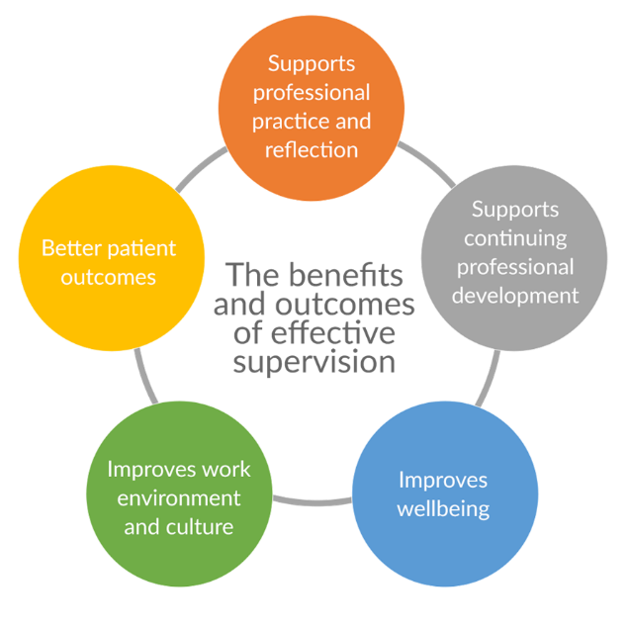

Recommendations:

It is recommended that practitioners are supported to attend supervision in protected time, within existing working hours, on a 6-8 weekly basis. If adopting a group supervision approach, then group size should be no more than 8 members (ideally only 4-6 members).

Confidentiality:
Any issues discussed within supervision sessions will be in confidence, unless there is anything disclosed that affects the well-being of the supervisee or is detrimental to patients, professional practice, the team, or the organisation. This caveat should be clearly discussed and documented as part of the “ground rules” of supervision sessions.

Governance/Record keeping:
A supervision policy should be in place.
A record should be kept of supervision activity including names, date of sessions and key topics covered (high level only). This can then be shared with the line manager and provides a record of supervision for regulatory purposes. It is a CQC recommendation that health care professional should be engaged in supervision within six months of being in post.
It is the responsibility of all healthcare staff to update their own CPD record.

