Foreword
Integrated Care Systems were set up to improve outcomes in population health, tackle inequality in outcome, experience and access and to join up the delivery of health and care services to improve the lives of our population. Working as a partnership of organisations across Northamptonshire will enable us to do this most effectively.

This document summarises agreements made between commissioners and healthcare providers which aim to ensure safe, effective patient care, mindful of contractual responsibilities and the need to optimize use of scarce resources.

We continue to welcome feedback on ways to improve ‘interface working’ through the Provider Single Point of Contact. We commend this document to you and hope that it fosters excellent working relationships across all our healthcare organisations in Northamptonshire.

Signatories – system MD/CMOs

Nil Sanganee | Signature:   | Date:  24th October  2025
Hemant Nemade | Signature:   | Date:  24th October 2025
Itai Matumbike | Signature:  | Date:  4th July 2025

Credits: This document has been developed and approved in partnership by:
- Northamptonshire ICB
- Northamptonshire Healthcare Foundation Trust
- University Hospitals Northamptonshire

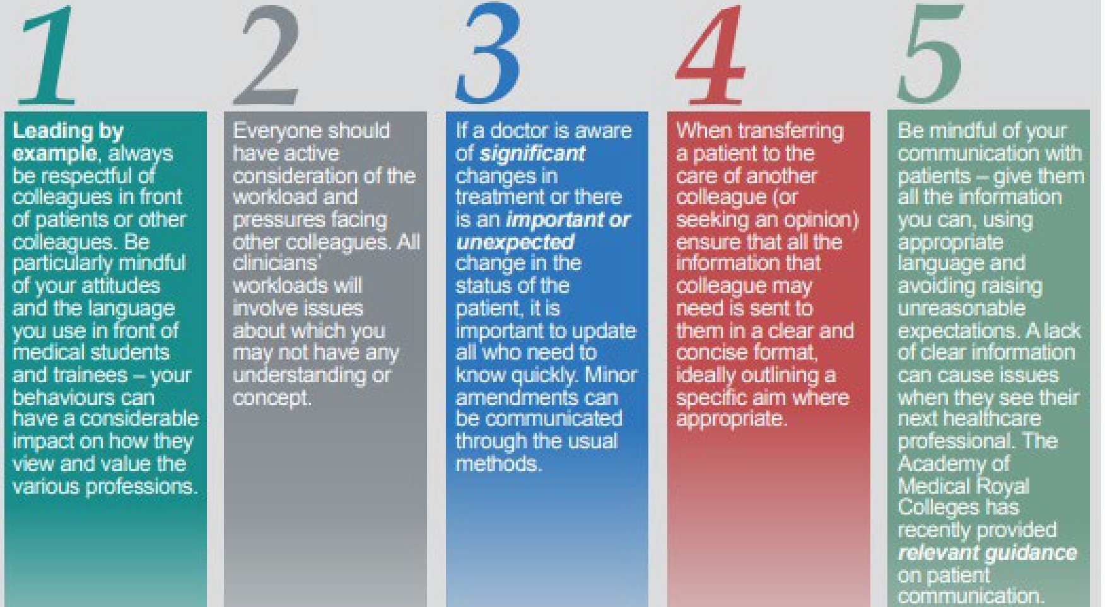
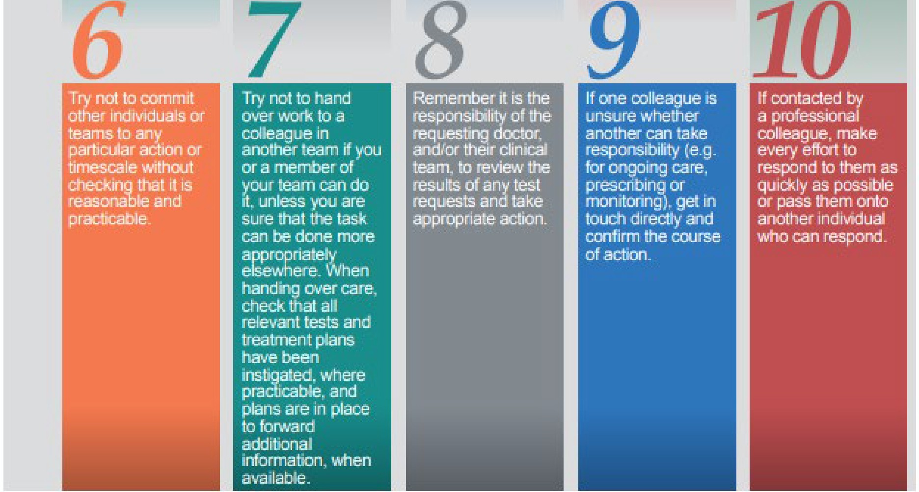
Ten principles to improve. effective communication and behaviors to maintain good professional relationships

Source: Royal College of General Practitioners

Principles for General Practice Secondary/Specialist care referrals
- Articulate why you are referring this patient. Are you looking for advice, diagnosis, treatment? What are the patient expectations?

- Ensure you send your referral to the correct service on ERS so that appropriate triage can take place and any delay in patient care can be avoided.

- Ensure an up-to-date medication list is available along with results of relevant investigations to date.

- If referring in order to access a diagnostic procedure, check the most up to date list of pathways for direct access opportunities (this could include endoscopy, ultrasound, MRI, CT scans, cardiology investigations or pediatric blood tests).

- Where appropriate for the GP to do in advance, please ensure prior approval has been applied for and agreed. Where a specialist is advising a treatment is needed, they are expected to complete the funding request, not send it to the GP for completion.

- Avoid using abbreviations and acronyms that are not understood in Secondary Care.

- Ensure that access to community phlebotomy/diagnostics is understood by all clinicians.

Appropriate General Practice assessments and pathways

- Check agreed referral pathways for pre-referral criteria and potential investigations.

- Ensure you have considered approved referral pathway options before considering referrals for certain conditions.

- Consider consultant advice and guidance prior to referral which could offer faster access to specialist knowledge and expertise and avoid long waiting times.

- Consider other sources of help and guidance such as Consultant Connect.

- Ensure patients requiring urgent appointment or 2-week appointment understand the pathway, expectations and are assessed for physical/frailty status where appropriate.

Patient communications

- Advise your patient that waiting lists may be long and that a referral into secondary care may result in an agreed management plan without being seen, a remote consultation or a traditional face to face appointment.

- Consider the use of Easy Read patient leaflets (where available) to inform about their condition.

Optimizing Long-Term Conditions before referral

- Consider BP control for hypertensives, glycemic control for those with diabetes etc. in order to reduce the impact of last-minute cancellations in pre-op clinic.

- Empower patients to optimize their own health in the waiting period-smoking cessation advice, weight advice etc. Consider referring patients to locally available services.

Principles for Secondary/ Specialist Care

Clear and timely communication to the GP following patient contacts (applies to all settings including hospital discharges, outpatient appointments and emergency department assessments)

- Highlight specific changes in medication and reasons for any changes.

- Avoid using abbreviations and acronyms that may not be understood in General Practice
- ​
- Be clear about what follow up is required, how it will be provided and how outstanding test results will be reviewed.

- Be explicit about any requests/actions for the GP.

- If you think the GP may need to review non-urgent symptoms which do not relate to the episode of care, then ask the patient to contact their GP to discuss this and let the GP know in your summary what you have advised. Do not pre-empt what the GP management plan may be or raise expectations with the patient about what might happen next.

- Do not request the GP to routinely carry out next steps on patients which relate to the primary indication for their secondary care episode.

- Undertake direct referrals to another specialty or organisation if you identify this should be done.

- Where appropriate for the GP to do in advance of referral they will have applied for individual funding. Where a specialist is advising a treatment is needed, they are expected to complete the funding request, not send it to the GP for completion.

- Whenever you identify an investigation should be repeated within the next 4 weeks: Advise the patient accordingly and request / review this investigation directly. It remains the responsibility of the clinician requesting all investigations to review and action them appropriately.

- Whenever you identify an investigation should be repeated after the next 4 weeks: Inform the GP which investigations are necessary (type and duration) and what course of action to undertake based on its outcome.

- Issue comprehensive discharge summaries that explicitly explain any medication changes (in full generic detail, compliant with ICB prescribing policy)
Specialist tests

- Ensure all hospital colleagues are aware of the current system in place to access community diagnostics and phlebotomy.

- Whenever surveillance investigations are required, or particular tests are needed prior to a specialist review, then request / review this investigation directly. It remains the responsibility of the clinician requesting all investigations to review and action them appropriately.

Fit notes / sick notes / Med 3’s

- Supply Fit Notes for the entire period required by the patient as soon as their need is anticipated. If a patient will need longer than 2 weeks off work please certify for the whole time frame not just 2 weeks.

Post-operative checks

- Organise and conduct follow up for all post-operative assessments.

Prescribing at discharge, from an outpatient appointment or ED assessment

- When the prescription is to be started within 28 days: Issue a 28-day (or nearest whole-pack) prescription or treatment supply. Advise the patient that their GP will take over repeat prescriptions after that point where that is needed. By exception, patients at particular risk (i.e. mental health crisis) may be issued with shorter prescription lengths.

- When the prescription is to be started after 28 days: Advise the patient that their GP will commence the prescription within a 28-day period and inform the GP of your recommendations.

- Where a shared-care agreement is required, ask the GP for agreement to continue issuing prescriptions once the patient is stabilised on that medication in accordance with the Shared Care Prescribing Policy.

- Ensure all medication intended for ongoing primary care issue conforms with the agreed ICB Prescribing Formulary.

- Provide explicit written communication in all cases to the GP practice within 7-10 days of your contact with the patient.

Please see Prescribing-and-MO_Standards-at-the-interface-between-primary-and-secondary-care_Apr-2025.pdf for the agreed standards for prescribing across care interfaces within Northamptonshire.

Self-discharges

- Patients who self-discharge are considered to be unwell and vulnerable. Put follow up plans in place for patients who self-discharge including arranging appropriate follow up in clinic is arranged and informing the GP.

- Provide appropriate discharge care and medication.

Patients who do not attend appointments

- Ensure all DNAs are not automatically discharged without clinical review in case they need your immediate review.

- Communicate options for direct re-booking of a further appointment (patient- initiated follow up) directly to the patient.

- Inform the GP that the patient has failed to attend.

Onward referral

- Wherever the problem relates to the original reason for referral (E.g., a patient referred to a respiratory specialist with breathlessness which, after review, is considered to be cardiac) or wherever a serious / urgent concern is identified: refer directly to the appropriate specialty.

- Wherever an unrelated and routine problem is identified: Inform the GP of your specific findings, concerns and recommended actions and advise the patient to routinely contact their GP to discuss your finding without recommending that specific future management will necessarily occur.

- Refer all patients discharged on a smoking cessation pathway to the community pharmacy Smoking Cessation Advanced Service once available.

Patient-initiated re-referral
- Upon discharge, specify conditions / criteria upon which patients can request direct re-booking of a further appointment without GP input (patient-initiated follow up) alongside the process required (this would normally exist for a 12- month period following discharge).

Points of contact

- Provide a patient point of contact system to deal with patient queries relating to all facets of their care (including following up on results, outpatient queries, appointment booking, etc.).

- Provide a timely clinical point of contact system to deal with clinical queries from primary and community care that is rapid enough to respond to requests regarding inappropriate work transfer.

Principles for Community Care (NHFT)

Clear and timely communication to the GP following patient contacts

- Highlight specific management changes and recommendations that will influence long-term care to the GP.

- Be clear about what follow up is required, how it will be provided and how outstanding test results will be reviewed.

- Be explicit about any requests/actions for the GP.

- If you think the GP may need to review non-urgent symptoms which do not relate to the episode of care, then ask the patient to contact their GP to discuss this and let the GP know. Do not pre-empt what the GP management plan may be or raise expectations with the patient about what might happen next.

- Do not request the GP to routinely carry out next steps on patients which relate to the primary indication for your involvement.

- Undertake direct referrals to another specialty or organisation if you identify this should be done.

- Whenever you identify an investigation should be repeated within the next 4 weeks: Advise the patient accordingly and request / review this investigation directly using your internal team hierarchy/resources if required. It remains the responsibility of the clinician requesting all investigations to review and action them appropriately.

- Whenever you identify an investigation should be repeated after the next 4 weeks: Inform the GP which investigations are necessary (type and duration) and what course of action to undertake based on its outcome.

Specialist tests

- Ensure all colleagues are aware of the current system in place to access community diagnostics and phlebotomy.

- Whenever surveillance investigations are required, or particular tests are needed prior to a specialist review, then request / review this investigation directly using your internal team hierarchy/resources if required. It remains the responsibility of the clinician requesting all investigations to review and action them appropriately.

Fit notes / sick notes / Med 3’s

- Supply Fit Notes using your internal team hierarchy if required for the entire period required by the patient as soon as their need is anticipated.

Prescribing

- When the prescription is to be started within 28 days: Issue a 28-day (or nearest whole-pack) prescription or treatment supply using your internal team hierarchy if required. Advise the patient that their GP will take over repeat prescriptions after that point where that is needed. By exception, patients at particular risk (i.e. mental health crisis) may be issued with shorter prescription lengths.

- When the prescription is to be started after 28 days: Advise the patient that their GP will commence the prescription within a 28-day period and inform the GP of your recommendations.

- Ensure all medication intended for ongoing primary care issue conforms with the agreed ICB Prescribing Formulary.

- Provide explicit written communication in all cases to the GP practice within 7-10 days of your contact with the patient.

Please see Prescribing-and-MO_Standards-at-the-interface-between-primary-and-secondary-care_Apr-2025.pdf
for the agreed standards for prescribing across care interfaces within Northamptonshire.

Self-discharges

- Patients who self-discharge are considered to be unwell and vulnerable. Put follow up plans in place for patients who self-discharge including arranging appropriate follow up in clinic is arranged and informing the GP.

- Provide appropriate discharge care and medication.

Patients who do not attend appointments

- Ensure all DNAs are not automatically discharged without clinical review.

- Communicate options for direct re-booking of a further appointment (patient- initiated follow up) directly to the patient.

- Inform the GP that the patient has failed to attend.

Onward referral

- Wherever the problem relates to the original reason for referral or wherever a serious / urgent concern is identified: refer directly to the appropriate specialty.

- Wherever an unrelated and routine problem is identified: Inform the GP of your specific findings, concerns and recommended actions and advise the patient to routinely contact their GP to discuss your finding without recommending that specific future management will necessarily occur.

Patient-initiated re-referral

- Upon discharge, specify conditions / criteria upon which patients can request direct re-booking of a further appointment (patient-initiated follow up) alongside process required (this would normally exist for a 12-month period following discharge).

