
Northamptonshire Healthcare NHS Foundation Trust Corporate Preceptorship Programme

This programme comprises 7 training days delivered by colleagues from different departments and focuses on topics relevant to all registered healthcare professionals. Ideally Day 1 should be completed first and the others can be completed in any order, although it might be more helpful to complete Day 6 towards the end of the Preceptorship period.
Day 1 Introduction to Preceptorship
This session is delivered every month by the Preceptorship Team and introduces the preceptee to the expectations of the Corporate Preceptorship Programme and their individual clinical preceptorship as close as possible to their start date.

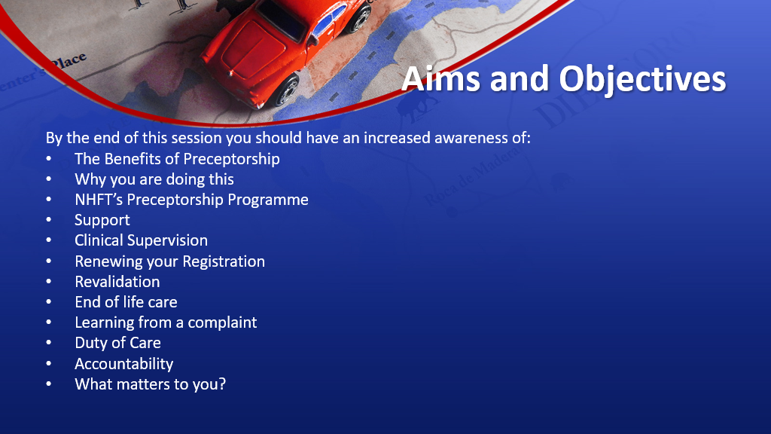

Day 2 Personal Effectiveness

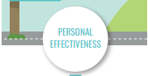

This whole day course, delivered by our Learning and Development Facilitators and part of Leadership Matters Programme, is all about YOU; how you utilise resources available and harness your talents, skills and energy, to be the ‘best version of you’. We will use the power of positive thinking, by exploring ‘Stephen Covey’s 7 Habits of Highly Effective People’, which will enable you to master the way you achieve both work and life goals.

What’s in it for me?
- You will identify your own professional effectiveness
- You will research ‘Stephen Covey’s 7 Habits of Highly Effect People’ and how you can use them to achieve your goal
- You will practise confidence techniques, which will grow and harness your talents, skills and energy
- You will look at your strengths and areas for development
- You will create a pictorial vision of your goal to ‘kick start’ your journey to success

What’s in it for the Service User?
- They will get the right person, in the right place, at the right time and with the right skills to effectively deliver an outstanding service

What’s in it for the Trust?
- We will focus on delivering an outstanding service by taking responsibility for our professional effectiveness.

Day 3 Understanding Professional Boundaries

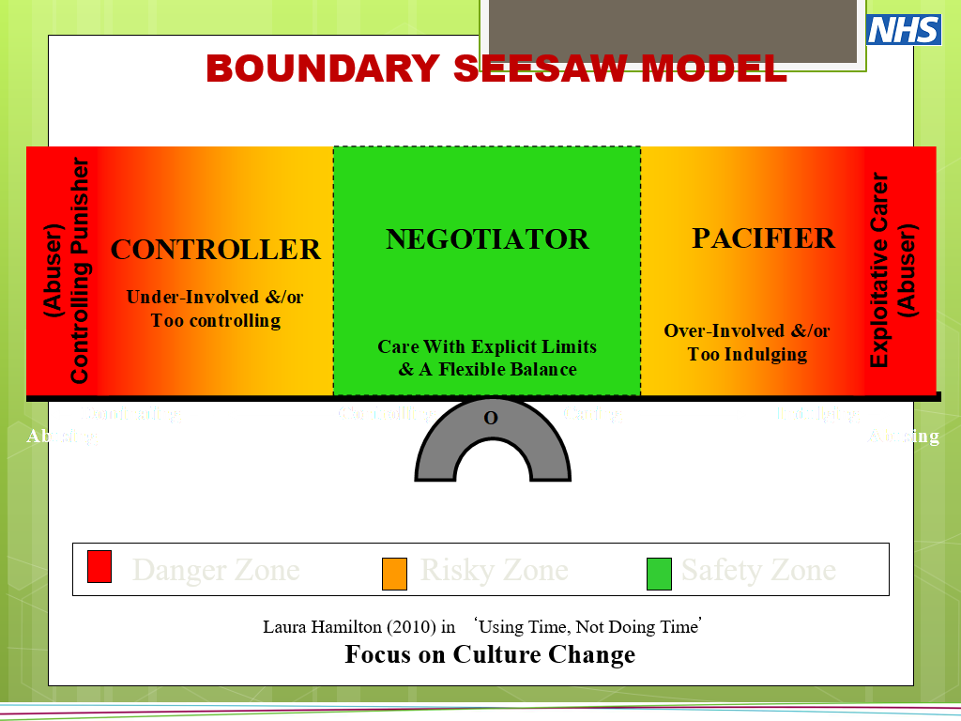

This whole day face to face training is delivered by a senior Clinical Psychologist, a Ward Matron and a member of the Pre and Post Registration Education and Training Team (PPETT). This is an opportunity to consider how boundaries relate to our professional lives and how they may be different depending on the clinical area where you work. Topics include:
- What is a boundary?
- Professional self – professional frameworks and responsibilities
- Therapeutic boundaries
- Power imbalances
- Our responsibilities in setting boundaries
- What to do when things go wrong
- How to recognise when we are ‘pulled out of shape’ and warning signs
- Wise mind and drama triangle
- Reflection, supervision and taking action if needed
- Introduction to personality disorders
- Different styles of interaction and boundary seesaw model
- Personal planning

Day 4 Record Keeping and the Law

Either: Healthcare Records from a Legal Perspective
This 3-hour virtual course via Microsoft Teams is delivered by an experienced healthcare lawyer and facilitated through NCORE (National Centre of Rehabilitation Education). The training will analyse and explain the accountability of the Healthcare Professional, and the different ways in which records can be examined. The professional standards and legal requirements which apply to record keeping will be explained. Common mistakes in record keeping will be highlighted through discussion and consideration of case studies.
Key Learning Points:
- Working to make records an integral part of professional care.
- Maintaining simple, accurate and professional records.
- Writing with the reader in mind.
- Records and professional accountability.
- Ensuring record entries are evidence based.
- Maintaining professional standards and complying with legal requirements.
- Changes in the method of data capture
- Highlighting common mistakes.

Or: Healthcare Records on Trial
Healthcare Records on Trial is a whole day face to face course which incorporates the above session ‘Healthcare Records from a Legal Perspective’ but in addition gives preceptees an opportunity to participate in a mock court session and to experience being cross-examined in the witness stand by our experienced healthcare lawyer!

Day 5 Leadership in the NHS - Morning session

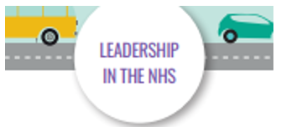
This 4-hour course is delivered by our Learning and Development Facilitators as part of our Leadership Matters training series and looks at the need to deliver leadership for the overall system and not just leading in your own, individual teams and services. This involves becoming more comfortable with sharing and distributing leadership and the ability to cope with chaos and complexity

What’s in it for me?
- You will explore the past concept of NHS leadership and lessons learnt and why the NHS has changed its leadership style
- You will identify the benefits and challenges towards distributed and systems leadership
- You will discuss and reference elements from key documents
- You will consider the skills, characteristics, and behaviours that Leaders have and give rational thoughts to why
- You will create an action plan to take changes forward in your team or service area

What’s in it for the Service User?
- They will interact with staff who feel valued and motivated to be a leader and utilise their skill set across all levels of the Trust

What’s in it for the Trust?
- We will have highly effective leaders who distribute and lead in line with the Trust’s 5,4,3,2,1 roadmap

Day 5 PLACE, DIGBQ and Managing Change – afternoon session
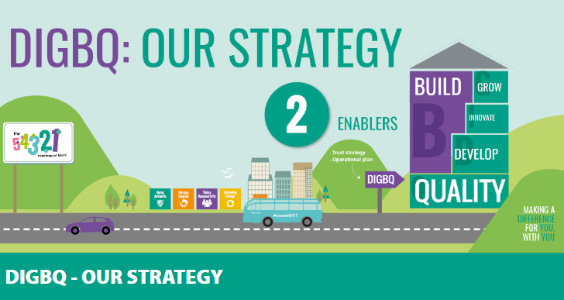
This 3-hour session is facilitated by an experienced member of NHFT’s Business Unit. It augments the morning session by looking at how care is delivered across Northamptonshire and is constantly evolving to meet the health and care needs of the local population.
Preceptees will learn about NHFT’s Strategy, the organisation of care, some of the developing services and initiatives and actively encouraged to be innovative, sharing their ideas to improve care delivery.
As the NHS is in a constant state of change this session also introduces ways of understanding how to manage change.

Day 6 Supporting Students

This is a whole day course, delivered by our Learning Environment Facilitators in the PPET Team predominantly focused on preparing the preceptee to become a supervisor of nursing and associate nursing students.
The morning session focuses on the Nursing and Midwifery Council (NMC) standards and the record keeping aspect of supporting students. The afternoon session will focus on the practicalities of supporting students which might also be helpful for Allied Health Preceptees supporting AHP students.
Day 7 Clinical Decision Making

This whole day session is delivered by members of the PPET team with the aims of:
- Supporting the preceptee in making sound clinical decisions
- Understanding how we make decisions
- Introducing clinical decision-making theories
- Introducing a decision-making tool to help the preceptee analyse their decisions
- Understanding how decisions are made in a team setting
- Understanding the benefits and challenges of making clinical decisions in a team setting

